

|  |  |
| --- | --- |
| Course Number and Name:  ME 747 | |
| Semester and Year:  Fall 2017 | Name of Lab Instructor:  Alireza Ebadi |
| Lab Section and Meeting Time:  Section 2B, Tuesday 2-5 pm | Report Type:  Internal Group Report |
| Title of Experiment:  Velocity and Position Sensors: LVT and LVDT Characterization, Parameter Identification | |
| Date Experiment Performed:  10/17/17 | Date Report Submitted:  10/31/17 |
| Names of Group Members:  Zhangxi Feng  Simon Popecki  Reilly Webb | Grader's Comments: |
| Grade: |

Table of Contents

Objectives 3

Executive Summary 4

Theory and Experimental Methods 5

Results and Discussion 11

Conclusions 22

References 24

Appendices 24

List of Figures

Figure 1: 1st Break Frequency Approximation. The larger time division data was used. 7

Figure 2: 2nd Break Frequency Approximation. The smaller time division data was used. 7

Figure 3: LVDT Diagram 9

Figure 4: DAQ 10

Figure 5: Plot of LVT signal 11

Figure 6: LVT measurement converted velocity and integrated 12

Figure 7: Damped portion of the foam 13

Figure 8: Coil 1 and coil 2 downward deflection 14

Figure 9: Coil 1 and coil 2 null output 14

Figure 10:Coil 1 and coil 2 upward output 15

Figure 11: Amplitude modulated coil outputs 16

Figure 12: Demodulated Signal 16

Figure 13: Controlled Masses 17

Figure 14: Controlled Deflections 18

Figure 15: Weight vs. Deflection of the beam 19

Figure 16: Theoretical Bode Diagram of the Low Pass Filter 20

Figure 17: Experimental frequency response 21

Figure 18: Theoretical Frequency Response 22

List of Tables

Table 1: Controlled mass loading and output voltage measurements 18

Table 2: Controlled deflections and output voltage measurements 18

# Objectives

The characteristics of a mass-spring-damper system were determined through the use of a linear velocity transducer (LVT) that produces a voltage proportional to the velocity of a magnetic core. Next, the properties of a linear variable differential transformer were investigated by calibration through weights and beam deflection. The effects of modulation and filtering were also observed. Experimental frequency response of the system was then determined using Lab View Signal Express.

# Executive Summary

In part 1, the parameters of the linear velocity transducer (LVT) were investigated and calculated. It was discovered that the LVT’s output (velocity) had a linear slope (acceleration) during the first 3 cycles, suggesting the mass went through free fall 3 times before it remained on the foam. The velocity profile and integrated displacement profile together showed the mass had maximum displacement and zero velocity at the lowest positions in the cycle; the mass also had maximum velocity and zero displacement when the mass reached the damped starting heights and upon impact with the foam. The sensitivity of the LVT was found by linearly fitting the free fall to find the slopes and compare to the expected gravitation acceleration and it was found to be 0.1224 V / (in/s). The following system parameters were calculated from the results: the damping ratio was found to be 0.113, the damped natural frequency to be 77.3 rad/s, the undamped natural frequency was found to be 77.8 rad/s, the spring constant was found to be 2.588 lbf/(in), and the damping coefficient was found to be 0.09 lbf/(ft/s). The spring constant and damping coefficient are found from the second order response portion of the output. The average damping force was found to be proportional to the velocity upon impact with the foam with the highest average damping force to be 0.223 lbf at 29.6 ft/s. The values are negative indicating the mass was falling downwards.

In part 2, the parameters of the linear variable differential transformer (LVDT) were investigated and calculated. It was discovered that for this E500 series Measurement Specialties LVDT, coil 1 generated more voltage when the beam is deflected downwards and coil 2 generated more voltage when the beam is deflected upwards. The total amount of voltage generated between the two coils seemed to remain constant as the voltage output seemed to be the same when the beam is not deflected. After the low-pass filter filtered out the noise in the signals, it was clear that the LVDT generated a positive voltage when the beam was deflected upwards, a negative voltage when the beam was deflected downwards, and, as expected, generated approximately zero volts when the beam was not deflected. The low-pass filter RC circuit had a break frequency of 213 rad/s suggesting the noise in the system had frequencies above the 213 rad/s. Furthermore, the LVDT’s responses to controlled loads and controlled deflections were measured. The results showed the output voltage and the input conditions had a highly linear correlation with coefficient of determination, R2, values of 0.9991 and 1.0 respectively for loads and deflections. This linearity is expected to hold true when the input signal frequency is within the bandwidth of the LVDT and the low-pass filter. Relating the loads to the deflections directly yielded the spring constant of the system to be 166.5 lbf/in. The same process also yielded the sensitivity of the LVDT to deflection to be 2.96 V/in. The damping ratio of the system was found to be .005, the natural frequency was found to be 191.5 rad/s, and the effective mass of the system was calculated to be 0.0045 g. Since the low-pass filter had a break frequency of around 200 rad/s, it would just barely not affect the output of the LVDT which was operating at 192 rad/s. Finally, the LVDT’s break frequencies were found to be 308 Hz and 47.5 kHz. Since the beam’s frequency was much lower than the LVDT’s operational bandwidth, the output was modulated by a carrier frequency at 2.5 kHz in order to be inside the flat region.

# Theory and Experimental Methods

**Theory**

1. Linear Velocity Transducer

LVT measures velocity by producing a voltage that is proportional to the velocity of a permanent magnet core moving through a coil as described by the Faraday’s law of induction:

$$emf=-N\frac{dϕ}{dt}$$

Dropping a mass connected to the LVT onto a foam will initially behave like a free fall mass on a spring. After enough energy is lost, the mass will remain on the foam and the output will become a second order frequency response. From the frequency response, the following parameters can be determined:

$$ω_{n}=\frac{ω_{d}}{\sqrt{1-ζ^{2}}}$$

$$k=ω_{n}^{2}*m$$

$$B=2*ζ*\frac{k}{ω_{n}}$$

$$F_{avg}=B*v_{i}$$

Where the average damping force is found with the impact velocity times the damping coefficient.

The sensitivity of the LVT can be determined from the free fall sections since the LVT measures velocity and a constant gravitational acceleration is expected during free fall, suggesting the free fall sections of the LVT velocity output should be linear.

* 1. And 2.2 LVDT System Characteristics and Calibration

LVDT contains a magnetic conductor metal core that moves through coils containing current, similar to the principles of a transformer. The current in the coil produces a magnetic field and the motion of the core material as described by Faraday’s law of induction as well as the mutual inductance between the coils.

The linearity of the LVDT can be found with the coefficient of determination

$$R^{2}=1-\frac{\sum{{\left(y-y_{fit}\right)}^{2}}}{\sum{{\left(x-\overline{x}\right)}^{2}}}$$

Both calibrations resulted in an $R^{2}$ of about 1, meaning that they are very linear.

Spring constant, k, was found through Hook’s law

$$k=\frac{F}{x}$$

In this case, this was determined through finding the slope of the fitted line to the weight to displacement calibration data.

Sensitivity was found in a similar fashion, using the slope of the voltage to deflection line

$$Sensitivity=\frac{V}{x}$$

The damping ratio can then be found from the raw data using the log decrement method on any two successive peaks

$$ζ=\frac{1}{\sqrt{1+(\frac{2π}{δ})^{2}}} where δ=\frac{1}{n} ln⁡(\frac{x\left(t\right)}{x\left(t+nT\right)})$$

where $x(t)$ is the amplitude at time $t$, $T$ is the period, and $n$ is the number of positive successive peaks. The damped and undamped natural frequency can then be found as follows

$$ω_{d}=\frac{2π}{T}$$

$$ω_{n}=\frac{2π}{T\sqrt{1-ζ^{2}}}$$

Effective mass could then be calculated

$$M_{eff}=\frac{-k}{ω_{n}^{2}}$$

2.3 LVDT Frequency Response

The break frequencies were found by extrapolating a linear fit for the horizontal line for usable bandwidth in the magnitude plot. Then the intersection points with the sloped filtered magnitude lines were found such that the error with the actual curve is about 3 dB. The frequencies at these two points are the break frequencies. See Figure 1 and 2



Figure : 1st Break Frequency Approximation. The larger time division data was used.



Figure : 2nd Break Frequency Approximation. The smaller time division data was used.

The LVDT system follows the following transfer function

$$\frac{E_{o}(jω)}{E_{i}(jω)}=\frac{2R_{m}K_{m}xs/(R_{m}+2R_{s})R_{p}}{(\frac{L_{p}}{R_{p}}s+1)(\frac{2L_{o}}{R_{m}+2R_{s}}s+1)}$$

From the spec sheet:

$$R_{s}=408 Ω, { R}_{p}=162 Ω, R_{m}=1 MΩ$$

The transfer function is in standard form, so time constant relationships can be used with the s coefficients in the denominator. $R_{s}$ is the input impedance, $R_{s}$ is the output impedance, and $R_{m}$ is the measuring impedance

$$L_{p}=\frac{R_{p}}{2πf_{b1}}$$

$$L_{o}=\frac{{(R}_{m}+2R_{s})}{4πf_{b2}}$$

Usable bandwidth is between the break frequencies, 308 Hz – 47.5 kHz

The theoretical sensitivity for any frequency within this bandwidth is determined by taking the magnitude of the transfer function for that range.

$$Sensitivity={\left|\frac{E_{o}(jω)}{E_{i}(jω)}\right|}_{ω_{band}}=\frac{\sqrt{({\frac{2R_{m}K_{m}xω}{\left(R_{m}+R_{s}\right)R_{p}})}^{2}}}{\sqrt{(-{\frac{2L_{p}L_{o}ω^{2}}{R_{p}(R_{m}+2R_{s})}+1)}^{2}}+\sqrt{({ω(\frac{L_{p}}{R_{p}}+\frac{2L_{o}}{R_{m}+2R_{s}}))}^{2}}}$$

The sensitivity is defined from the bode plot as 0.0794 (-22 dB). Assuming x=0.1 in, the gain term $K_{m}$ is defined as follows

$$K_{m}=\frac{\left(R_{m}+R_{s}\right)R_{p}\sqrt{(.0794(\sqrt{(-{\frac{2L_{p}L_{o}ω^{2}}{R_{p}(R_{m}+2R_{s})}+1)}^{2}}+\sqrt{({ω(\frac{L_{p}}{R_{p}}+\frac{2L_{o}}{R_{m}+2R_{s}}))}^{2}}{))}^{2}}}{2R_{m}xω}=0.0372$$

The total gain for the transfer function (numerator coefficient) can be found from

$$Gain=\frac{2R_{m}K_{m}x}{R_{m}+2R_{s}R_{p}}=4.58e-05$$

**Experimental Methods**

1. **Linear Velocity Transducer**

The LVT system was hooked up to the oscilloscope such that the trigger position could record a significant change in velocity of the shaft. The shaft was then dropped about an inch, which caused it to bounce off the foam. The first few oscillations left the foam and returned to freefall, however it soon became in constant contact with the foam and the signal quickly decayed.

**2.1 LVDT Characteristics**



Figure : LVDT Diagram

The function generator was used to create an excitation voltage, which was a sin wave with an amplitude of 6V and a frequency of 2.5 kHz.

Next, both coil outputs were hooked up to the oscilloscope. The signals were investigated for a few different states: with the core at null, above null, and below null. The amplitude of the input voltage was then increased to 10 V, and a full wave demodulator was implemented. The signal was then “averaged” to get a single value that was proportional to displacement. This was made possible by a low-pass filter. Data was collected for the vibrating beam from both the demodulator and the filter output.

A FFT frequency plot was taken of the demodulated signal with the beam moving and not moving. The frequency scale was 4.9 – 5.1 kHz, with a time scale of 0.5 sec and 75K total data points.

2.2 LVDT System Calibration

The LVDT (Figure 3) was calibrated first by weight. A plastic bucket of known weight was incrementally filled with various weights up to 500g. The corresponding filter output was recorded for each increment.

Next, the LVDT was calibrated using incrementing deflections from a micrometer set up on the free end of the beam. Each micrometer measurement corresponded to a filtered output. Finally, an under-damped 2nd order response was collected by flicking the beam and recording the signal.

2.3 LVDT Frequency Response

An experimental frequency response was collected from the LVDT system by using Lab View Signal Express and a DAQ. This was accomplished **by sending broadband noise through the input of the circuit to test the whole spectrum of frequency inputs. The input was connected to the NI DAQ (Figure 4) output terminals. Refer to “Using LabView for Frequency Responses” by M.H. deLeon [1] for a more in depth procedure.**

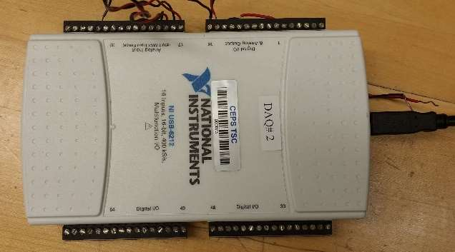

Figure : DAQ

# Results and Discussion

**1. Linear Velocity Transducer**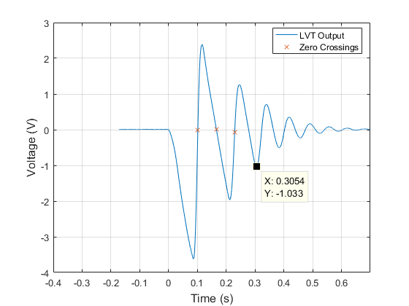

Figure : Plot of LVT signal

**The Motion Of Mass:**

During free fall, the slope of the velocity is linear, indicating there is a constant force acting on it in the negative direction – this is the force of gravity. The slope of the velocity measurements are negative, indicating by convention that the mass is falling. During initial impact with the foam, the velocity is still negative but begins to increase towards the positive direction, indicating the foam slows down the mass and slowly accelerates it at constant force (spring force) in the positive, upwards direction. When the velocity measurement crosses zero the first time at the leftmost labeled X point in Figure 5, the mass has reached the bottom of its trajectory inside the foam with maximum elastic potential energy and zero kinetic energy. Therefore, a short while after the X point the mass would bounce off the foam. At that moment, the mass would be travelling in the positive y direction and experience only experience the negative acceleration of gravity.

The Physical significance of the first three zero crossings are labeled by X in Figure 5. The first zero crossing is when the mass reached the lowest point inside the foam. The second zero crossing is when the mass reached the highest point after first bounce. The third zero crossing is when the mass reached the lowest point (with respect to each cycle) inside the foam. The first minimum voltage point is when the mass is about to hit the foam at a point where the gravitational potential energy is entirely converted to kinetic energy (maximum speed). The first maximum voltage point is when the mass reached the damped starting position where the undamped net displacement would be zero and velocity would be maximized.

After three free falls, the approximate time when the mass stopped bouncing off the foam is 0.31s. After that point, the negative displacement part of the velocity measurement appeared more like a second order damped output.

**Sensitivity of the Instrument:**

The MATLAB Polyfit linear regression function of the initial slope gives -47.251 V/s. With gravity, g = -386 in/sec2:

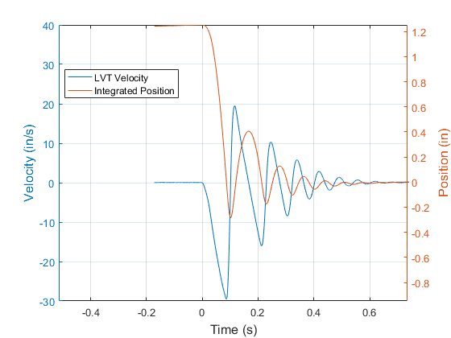

Figure : LVT measurement converted velocity and integrated

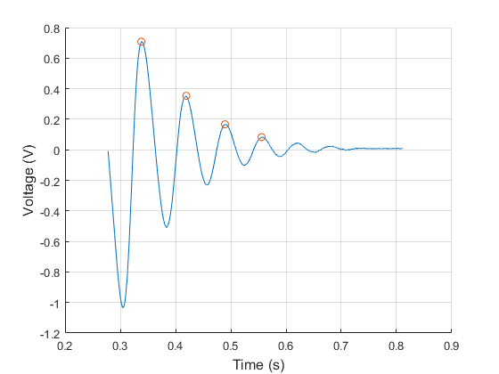Figure 7 shows the damped foam-mass system response. The circular peaks are used to determine the damping ratio and damped natural frequency. The spring constant is found using the equation: $k=ω_{n}^{2}*m$.

Figure : Damped portion of the foam

From the above results, the following LVT parameters were calculated:

$$m=74.9 g, ζ=0.1130$$

$$T=0.0813\frac{s}{cyc}, ω_{d}=\frac{2π}{T}=77.3188\frac{rad}{s}$$

$$ω_{n}=\frac{ω_{d}}{\sqrt{1-ζ^{2}}}=\frac{2π}{T\sqrt{1-ζ^{2}}}=77.8171\frac{rad}{s}$$

$$k=ω_{n}^{2}*m=453.5567\frac{kg}{s^{2}}=453.5657\frac{N}{m}=31.1\frac{lb_{f}}{ft}=2.588\frac{lb_{f}}{in}$$

The average force of impact when the shaft hits the foam would be equal to the damping force of the foam, which is relative to its damping coefficient:

$$B=2*ζ*\frac{k}{ω_{n}}=1.3171\frac{N}{m/s}=0.09025\frac{lb_{f}}{ft/s}$$

Using damping force formula: $F_{avg}=B*v_{i}$

Where $v_{i}$ is the velocity of the mass upon impact with the foam, using the first three minimum peaks in Figure 1 (since the first three falls are estimated to be free falls):

$$v_{i}=\left[-29.59, -16.03, -8.46\right] ft/sec$$

Which gives an average force

$$F_{avg}=\left[-0.223, -0.121, -0.064\right] lb_{f}$$

**2.1 LVDT Characteristics**

Figure 8 below shows a plot of coil 1 and coil 2 before amplitude demodulation: 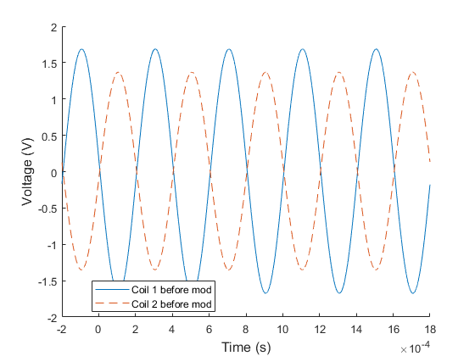

Figure : Coil 1 and coil 2 downward deflection

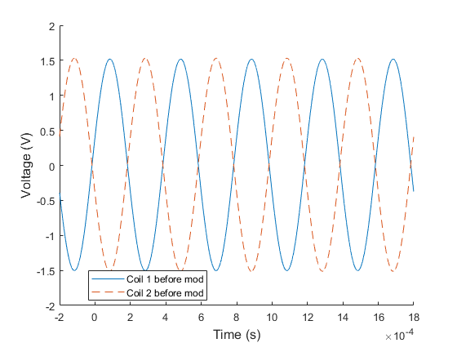

Figure : Coil 1 and coil 2 null output

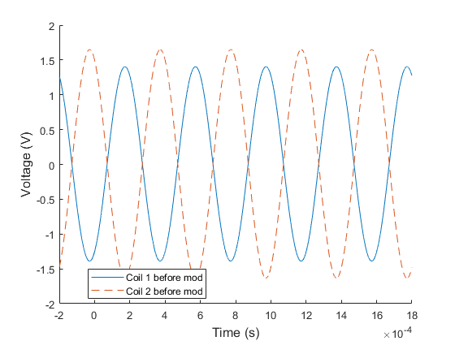

Figure :Coil 1 and coil 2 upward output

Figure 8 shows the coil outputs when beam is deflected downwards; Figure 9 shows the outputs when the beam is static (no deflection); and Figure 10 shows the outputs when the beam is deflected upwards. When beam is deflected downwards, coil 1 output has a higher amplitude than coil 2, suggesting the metal core is closer to coil 1 than coil 2, which facilitates higher magnetic flux and induces more current in coil 1’s circuit. Similarly, when the beam is deflected upwards, the core is closer to coil 2, resulting in a higher output amplitude. Conforming to this, when the beam is not deflected, both coils’ outputs have the same amplitude. This is characteristic behavior of an LVDT.

A phase-sensitive demodulator demodulated the modulated coil signals using diode Wheatstone bridges (eliminating negative portions of periodic signals). A modulated signal is one where the output is combined with a carrier wave to raise the signal to the detectable bandwidth range. Figure shows the demodulated result of the coil’s output signals from the LVDT’s excitation signal of 10 V sine wave at 2.5 kHz.

The diodes block currents in the opposite direction. Therefore, demodulation will result in signals all on one side, as shown by the almost M shaped signals for upwards and downwards deflections. The variations in the deflections as well as the no-deflection (null) state are results of the carrier frequency for the modulated signal.

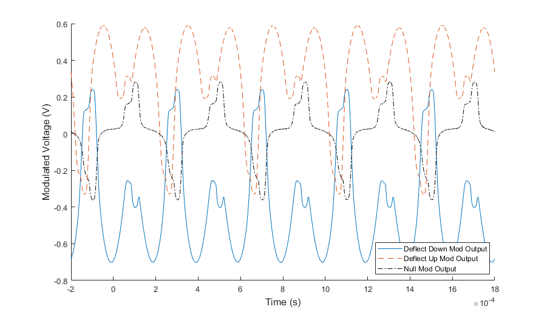

Figure : Amplitude modulated coil outputs

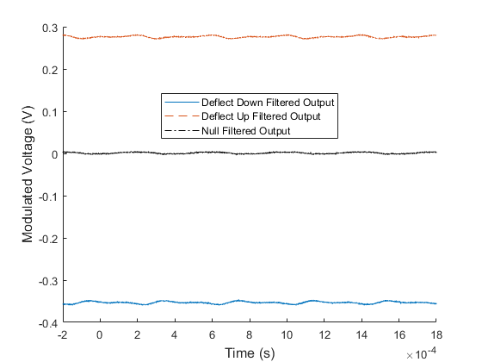

Figure : Demodulated Signal

The sensitive nature of the demodulation circuit calls for the need of a low-pass filter to remove the high frequency carrier wave in the output signal. This experiment used an RC circuit with a break frequency of 213 rad/s to act as the filter and the outputs are shown in Figure 12. It can be seen that when deflected upwards the output is positive, downwards is negative, and no deflection has an output of approximately zero.

2.2

Figure 13 and Figure 14 show the output voltage from the LVDT-beam setup at controlled loads, and controlled deflections. Both data are highly linear as shown with the linearly fitted lines. The coefficient of determination, $R^{2}$, value of the linear fits to the two sets of data are 0.9991 and 1.0 respectively. The coefficient equation is: $R^{2}=1-\frac{\sum{{\left(y-y_{fit}\right)}^{2}}}{\sum{{\left(x-\overline{x}\right)}^{2}}}$

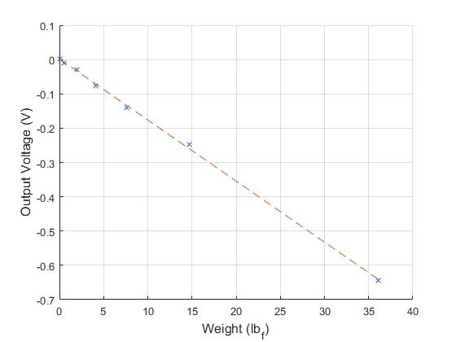

Figure : Controlled Masses

The high linearity suggests the slopes can be the sensitivity of the LVDT for loads and displacements. The original data of the two sets are shown in Table 1 and Table 2 below.

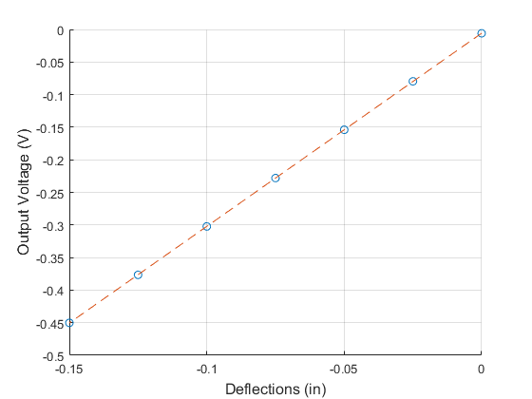

Figure : Controlled Deflections

Bucket mass = 7.65 g = 0.0169 lbm on Earth.

Table : Controlled mass loading and output voltage measurements

|  |  |
| --- | --- |
| Masses (lbm) [g]* | Voltage Output (mV) |
| 0 [0 g] | 1.335 |
| 0.0169 [7.65 g] | -10.475 |
| 0.0610 [27.65 g] | -28.59 |
| 0.1271 [57.65 g] | -76.09 |
| 0.2373 [107.65 g] | -140.55 |
| 0.4578 [207.65 g] | -247.43 |
| 1.1192 [507.65 g] | -643.76 |

* all values include the mass of the bucket, values in brackets are original measurements

Pounds mass is converted to pounds force by multiplying by 32.2 ft/s2.

Table : Controlled deflections and output voltage measurements

|  |  |
| --- | --- |
| Deflections (in) | Voltage Output (mV) |
| 0 | -5.9836 |
| -0.025 | -79.61 |
| -0.05 | -153.93 |
| -0.075 | -227.99 |
| -0.1 | -302.31 |
| -0.125 | -376.57 |
| -0.150 | -450.23 |

This linearity is only expected to hold true when the input signal frequency is within the bandwidth of the LVDT.

The spring constant, k has units of force/distance, or load/deflection, can be found after matching the voltage output response of weight to the voltage output response of the deflection.

The weight equivalent deflections are found to be:

|  |  |
| --- | --- |
| Weight (lbf) | Deflection (in) |
| 0 | 35.62 |
| 0.0169 | 14.32 |
| 0.0610 | 7.22 |
| 0.1271 | 3.67 |
| 0.2373 | 1.54 |
| 0.4578 | 0.12 |
| 1.1192 | -0.42 |

Polyfitting this data to a line gives a slope of 9166.5, suggesting the spring constant of the beam to be 166.5 lbf/in. The negative sign indicates weights are equivalent to negative deflections. The data and polyfitted line are shown in Figure 3:

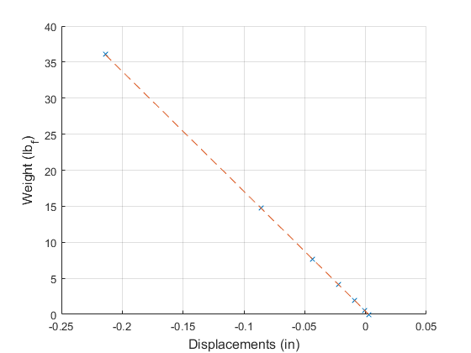

Figure : Weight vs. Deflection of the beam

The linearity of the data suggests the sensitivity of the LVDT for deflection to be equal to the slope of the voltage versus deflection fit line: 2.9643 V/in.

The damping ratio of the system was found to be .0050. The damped natural frequency was found to be 191.500 rad/s, and the undamped natural frequency (of the first mode of vibration) was found to be 191.533 rad/s. Finally, the effective mass of the system was calculated to be 0.0045 kg



Figure : Theoretical Bode Diagram of the Low Pass Filter

From the bode diagram of Low-pass filter, it can be seen that the LVDT output will only be affected by the filter when the input frequency is greater than approximately 200 rads/sec

**2.3 LVDT Frequency Response**



Figure : Experimental frequency response

Two break frequencies were extracted from the experimental bode response plot. $f_{b1}=1937.11\frac{rad}{s} (308.3 Hz)$ and $f_{b2}=298357 rad/s (47485 Hz)$. This was done by linearly fitting the curves at both sides of the break, and marking the peak of the cusp as the frequency.

From these values, the inductances $L_{o}=1.6772 H$ and $L_{p}=0.0836 H$ could be found. The specification sheet was used to determine the impedances. Based on the bode plot, the usable bandwidth is between the break frequencies, 308 Hz – 47.5 kHz.

The theoretical sensitivity for any frequency within this bandwidth is determined by taking the magnitude of the transfer function for that range. The sensitivity is defined from the bode plot as 0.0794, or -22 dB. Assuming x=0.1 in, the gain term $K_{m}$ is then equal to 0.0372.



Figure : Theoretical Frequency Response

The theoretical bode plot in figure 18 matches the experimental bode plot relatively closely. The sensitivity for both is very close at around -22 dB, as well as the locations of the break frequencies (when both are converted to rads/sec).

The core of the LVDT also has a resonant frequency that can add noise to the output signal. This resonant frequency can be an issue for the filter while the core is moving or force is applied to it. The filter also puts a ceiling on how high the input frequency can be while still giving a useful output.

If the input frequency gets below the first break frequency, the LVDT will filter out the signal and it won’t work.

# Conclusions

Jesse’s Conclusion:

The LVT outputs and the integrated results told the complete story of the mass’s movement. The first three zero crossings of the mass on the velocity profile were when the mass reached the minimum positions (maximum potential energy and zero kinetic energy), when the mass reached the damped starting height (maximum gravitational potential energy and zero kinetic energy), as well as when the mass reached the damped minimum position again. The zero crossings on the positive slopes corresponded to decreasing heights and indicated the loss of energy during motion from air friction and impact with the foam due to damping. After only three cycles, the mass lost too much energy to bounce off the foam and began its second order frequency response inside the foam until it lost almost all of its initial potential energy to reach steady state. The outputs were reasonable and matched the expectations well.

The LVDT outputs showed the LVDT’s coil 1 is closer to the magnetic core than coil 2 when the beam is deflected downwards and vice versa. The overall total voltage output between the two coils remained constant as the null position showed two coils output the same velocity and the deflected positions showed the two coils change amplitude by approximately the same amount. The natural frequency of the beam was at 191 rad/s, which was much lower than the bandwidth of the LVDT (between 1937 rad/s and 297,357 rad/s). This was why the outputs were initially modulated by a carrier signal at 2.5 kHz. The outputs were then demodulated and filtered to produce a steady signal showing the LVDT would generate positive output when the beam was deflected upwards and negative when it was deflected downwards. The low-pass filter filtered out the 2.5 kHz high frequency signals and returned the 191 rad/s low frequency signal of the beam. However, when the core is moving, it could generate higher or lower frequencies due to transient responses and lead to additional noise in the outputs.

Simon Popecki:

The Linear Velocity Transducer used in this lab had a sensitivity of 2.96 Volts per inch, making it sensitive enough to be useful in most dynamic measurement scenarios under an inch. A major benefit of the LVT system is the lack of input voltage required – the coil is able to provide its own power output directly to an op-amp, reducing the complexity of the metrological system.

Linear Varying Differential Transformers provide the ability to measure under static conditions, at the expense of added complexity – there is a required input of a periodic alternating current of a specific frequency which may not be available or easily set up in some applications outside of a lab, nor may the diode rectifier bridge be available. LVDT systems have a bandwidth – a limited frequency range of measurement capability. The larger the bandwidth, the lower the resolution of the sensor. The bandwidth of the LVDT system used in this lab was roughly 47 kHz. The mass of the core in an LVDT must be considered along with the electrical properties when applied to a moving system – the core may have enough weight to impact measurements.

Reilly:

For the most part, the gap between theoretical and experimental results remained low throughout this lab. This could be seen through looking at the bode plots in section 2.3.

This lab did a good job of demonstrating the pros and cons of each sensor. One big perk of the LVT was that it did not require an excitation voltage. However, the signal must be integrated if you want to find the position of the shaft, and that opens up more chances for error and uncertainty.

If this experiment were to be repeated, I would measure the true inductance of the LVDT. These values would be useful in checking our analysis techniques and calculations without making the analysis less challenging.

# References

[1] DeLeon, M H. “Using LabView for Frequency Responses.” 3 Sept. 2014.

# Appendices

clear all; close all;

%% Part 1

% loading data

lvtdata = importdata('LVT v(t).lvm','\t',29);

lvtT = lvtdata.data(:,1);

lvtV = lvtdata.data(:,2);

% cut out the extra parts

lvtT = lvtT(1:1500);

lvtV = lvtV(1:1500);

restVStd = std(lvtV(1:200));

zeroCrossInd = zeros(1,3);

% Find where the first free fall begin

iniSlopeStartInd = 0;

iniSlopeEndInd = 0;

for i = 1:length(lvtV)

if (lvtV(i) < 0-restVStd)

iniSlopeStartInd = i;

% find where the first free fall ends

for j = iniSlopeStartInd:length(lvtV)

if (lvtV(j+1) - lvtV(j) > 0)

iniSlopeEndInd = j;

% Find the next three zero crossings

n = 1;

for k = iniSlopeEndInd:length(lvtV)

% switch signs due to data going up and down

if (mod(n,2) == 1 && lvtV(k) > 0)

zeroCrossInd(n) = k-1;

n = n + 1;

elseif (mod(n,2) == 0 && lvtV(k) < 0)

zeroCrossInd(n) = k-1;

n = n + 1;

elseif (n == 4)

break;

end

end

break;

end

end

break;

end

end

lvtT = lvtT - lvtT(iniSlopeStartInd);

% 1 a) Plot LVT Output Voltage vs. Time

figure(1);

plot(lvtT,lvtV);

hold on;

plot(lvtT(zeroCrossInd),lvtV(zeroCrossInd),'X');

grid on;

xlim([-0.4 0.7]);

xlabel('Time (s)','FontSize',12);

ylabel('Voltage (V)','FontSize',12);

legend('Location','best','LVT Output','Zero Crossings');

%% finding the slopes

p = polyfit(lvtT(iniSlopeStartInd:iniSlopeEndInd),lvtV(iniSlopeStartInd:iniSlopeEndInd),1);

% see document for origin of formula

sens = p(1)/-386; % [V / in/s] LVT sensitivity

lvtVelocity = lvtV/sens;

% integrate the signal

lvtPosition = cumtrapz(lvtT,lvtVelocity);

% adjust to rest at 0

lvtPosition = lvtPosition - mean(lvtPosition(1200:end));

% 1 f)

figure(2);

grid on;

xlim([-0.5 0.75]);

yyaxis left;

plot(lvtT,lvtVelocity);

ylabel('Velocity (in/s)','FontSize',12);

ylim([-30 40]);

yyaxis right;

plot(lvtT,lvtPosition);

ylim([-0.8 1.4]);

xlabel('Time (s)','FontSize',12);

ylabel('Position (in)','FontSize',12);

legend('Location','best','LVT Velocity','Integrated Position');

%% 1 g) Find damping ratio, damped frequency, and spring constant

% Location the fourth zero crossing as start of damped response

for i = zeroCrossInd(end)+1:length(lvtV)

if (lvtV(i) < 0)

dampStart = i;

break;

end

end

% reassign data range

dampedT = lvtT(dampStart:end);

dampedV = lvtV(dampStart:end);

% find the peaks

[maxV,~] = peakdet(dampedV,0.1);

maxV = maxV(2:end,:); % remove the first peak

TV = diff(dampedT(maxV(:,1)));

TV = TV(1); % use the first damped period

n = 4; % use all 4 peaks

sigmaV = (1/(n-1))*log(maxV(1,2)/maxV(4,2));

zetaV = sigmaV/sqrt(4*pi^2 + sigmaV^2); % the damping ratio

wdV = 2*pi/TV; % The damped frequency in rad/s -> 2pi rad/cyc div s/cyc

wnV = wdV/sqrt(1 - zetaV^2); % undamped natural frequency

mass = 74.9/1000; % [kg]

mass_english = mass*2.20462;

k = wnV^2*mass; % 1/(wn^2) = m/k -> k/m = wn^2 -> k = m*wn^2

k_english = k*2.20462/32.2; % convert from kg/s^2 to lbf/ft

figure(3);

hold on;

plot(dampedT,dampedV);

plot(dampedT(maxV(:,1)),dampedV(maxV(:,1)),'O');

grid on;

xlabel('Time (s)','FontSize',12);

ylabel('Voltage (V)','FontSize',12);

%% 1 h)

B = 2*zetaV*k/wnV; % B/k = 2*zeta/wn, [N/m/s]

B_english = B/3.28084*0.224809; % converted to [lbf/ft/s]

% damping force: Favg = B*vi

[maxVel,minVel] = peakdet(lvtVelocity,1);

vi = minVel(1:3,2);

Favg = B_english*vi/12; % [lbf / ft/s] * [in/s] = lbf in/ft = lbf*12;

% delV = 18.53+29.5;%lvtVelocity(maxVel(2,1)) - lvtVelocity(minVel(1,1));

% delT = -0.03489+0.06897;%lvtT(maxVel(2,1))-lvtT(minVel(1,1));

% Favg2 = mass_english*delV/delT/12; % currently has units of lbm ft/s^2 = lbf

figure(4);

hold on;

plot(lvtT,lvtVelocity);

plot(lvtT(maxVel(:,1)),lvtVelocity(maxVel(:,1)),'O');

plot(lvtT(minVel(:,1)),lvtVelocity(minVel(:,1)),'O');

clear all;

close all;

%% Part 2.1

% loading files

down = importdata('Deflect down.lvm','\t',32);

downData = down.data;

up = importdata('Deflect up.lvm','\t',32);

upData = up.data;

null = importdata('Null.lvm','\t',32);

nullData = null.data;

downMod = importdata('demod and filter below null.lvm','\t',32);

downModData = downMod.data;

upMod = importdata('demod and filter above null.lvm','\t',32);

upModData = upMod.data;

nullMod = importdata('demod and filter null.lvm','\t',32);

nullModData = nullMod.data;

% deflect down breakdown

coilOneDownTime = downData(:,1);

coilOneDownVolt = downData(:,2);

coilTwoDownTime = downData(:,3);

coilTwoDownVolt = downData(:,4);

% mod:

downModTime = downModData(:,3);

downModVolt = downModData(:,4);

downFiltTime = downModData(:,1);

downFiltVolt = downModData(:,2);

% deflect up breakdown

coilOneUpTime = upData(:,1);

coilOneUpVolt = upData(:,2);

coilTwoUpTime = upData(:,3);

coilTwoUpVolt = upData(:,4);

% mod:

upModTime = upModData(:,3);

upModVolt = upModData(:,4);

upFiltTime = upModData(:,1);

upFiltVolt = upModData(:,2);

% null breakdown

coilOneNullTime = nullData(:,1);

coilOneNullVolt = nullData(:,2);

coilTwoNullTime = nullData(:,3);

coilTwoNullVolt = nullData(:,4);

% mod:

nullModTime = nullModData(:,3);

nullModVolt = nullModData(:,4);

nullFiltTime = nullModData(:,1);

nullFiltVolt = nullModData(:,2);

%% Part a), before mod

% plot of coil 1 and 2 in deflect down position and mod output

figure(1);

hold on;

plot(coilOneDownTime,coilOneDownVolt);

plot(coilTwoDownTime,coilTwoDownVolt,'--');

xlabel('Time (s)','FontSize',12);

ylabel('Voltage (V)','FontSize',12);

legend('Location','best','Coil 1 before mod','Coil 2 before mod');

% plot of coil 1 and 2 in deflect up position and mod output

figure(2);

hold on;

plot(coilOneUpTime,coilOneUpVolt);

plot(coilTwoUpTime,coilTwoUpVolt,'--');

xlabel('Time (s)','FontSize',12);

ylabel('Voltage (V)','FontSize',12);

legend('Location','best','Coil 1 before mod','Coil 2 before mod');

% plot of coil 1 and 2 in null position and mod output

figure(3);

hold on;

plot(coilOneNullTime,coilOneNullVolt);

plot(coilTwoNullTime,coilTwoNullVolt,'--');

xlabel('Time (s)','FontSize',12);

ylabel('Voltage (V)','FontSize',12);

legend('Location','best','Coil 1 before mod','Coil 2 before mod');

% plot of all mod outputs

figure(4);

hold on;

plot(downModTime,downModVolt);

plot(upModTime,upModVolt,'--');

plot(nullModTime,nullModVolt,'k-.');

xlabel('Time (s)','FontSize',12);

ylabel('Modulated Voltage (V)','FontSize',12);

legend('Location','best','Deflect Down Mod Output','Deflect Up Mod Output','Null Mod Output');

% plot of all filtered outputs

figure(5);

hold on;

plot(downFiltTime,downFiltVolt);

plot(upFiltTime,upFiltVolt,'--');

plot(nullFiltTime,nullFiltVolt,'k-.');

xlabel('Time (s)','FontSize',12);

ylabel('Modulated Voltage (V)','FontSize',12);

legend('Location','best','Deflect Down Filtered Output','Deflect Up Filtered Output','Null Filtered Output');

%% Part 2.2 a) - c)

% data from lab

mass_bucket = 7.65; % [kg]

total_masses = ([500,200,100,50,20,0,-mass_bucket] + mass_bucket)/1000*2.20462;

total_weight = total_masses*32.2; % [lbm -> lbf] * 32.2 ft/s^2

VoutWeight = [-643.76,-247.43,-140.55,-76.09,-28.59,-10.475,1.335]/1000; % [V]

deflections = [0,-0.025,-0.05,-0.075,-0.1,-0.125,-0.150]; % [in]

VoutDef = [-5.9836,-79.61,-153.93,-227.99,-302.31,-376.57,-450.23]/1000; % [V]

% linearity of the curves

% fit the curves

p1 = polyfit(total_weight,VoutWeight,1);

p2 = polyfit(deflections,VoutDef,1);

% make the fit lines

weight = total_weight;

Vw = weight*p1(1) + p1(2);

def = deflections;

Vdef = def*p2(1) + p2(2);

% R squared formula

Rsqw = 1 - sum((VoutWeight - Vw).^2)/sum((VoutWeight - mean(VoutWeight)).^2); % weight

RsqD = 1 - sum((VoutDef - Vdef).^2)/sum((VoutDef - mean(VoutDef)).^2); % deflection

% finding spring constant K

% match weight to displacement

def_equivalent = (Vw - p2(2))/p2(1);

% fit the matched displacement-weight data

p3 = polyfit(def_equivalent,weight,1);

K = p3(1);

def_eq = def_equivalent;

w = def_eq*p3(1) + p3(2); % make the best fit line

figure(6);

hold on;

plot(total_weight,VoutWeight,'X');

plot(weight,Vw,'--');

grid on;

xlabel('Weight (lb_f)','FontSize',12);

ylabel('Output Voltage (V)','FontSize',12);

figure(7);

hold on;

plot(deflections,VoutDef,'O');

plot(def,Vdef,'--');

grid on;

xlabel('Deflections (in)','FontSize',12);

ylabel('Output Voltage (V)','FontSize',12);

figure(8);

hold on;

plot(def_equivalent,weight,'x');

plot(def_eq,w,'--');

grid on;

xlabel('Displacements (in)','FontSize',12);

ylabel('Weight (lb_f)','FontSize',12);

%% Part 2.2 d)

% load data

vibrationData = importdata('2_2_4 Vibrating.lvm','\t',29);

vibrationT = vibrationData.data(5000:38000,1);

vibrationV = vibrationData.data(5000:38000,2);

% usual zeta and frequency calculations using log decrement

[maxV,~] = peakdet(vibrationV,0.1);

TV = diff(vibrationT(maxV(:,1)));

TV = TV(1);

n = 4; % using all the peaks

sigmaV = (1/(n-1))*log(maxV(1,2)/maxV(4,2));

zetaV = sigmaV/sqrt(4*pi^2 + sigmaV^2); % the damping ratio

wdV = 2*pi/TV; % The damped frequency in rad/s -> 2pi rad/cyc div s/cyc

wnV = wdV/sqrt(1 - zetaV^2); % undamped natural frequency

figure(9);

hold on;

plot(vibrationT,vibrationV);

plot(vibrationT(maxV(:,1)),vibrationV(maxV(:,1)),'O');

xlabel('Time (s)','FontSize',12);

ylabel('Voltage (V)','FontSize',12);

%% part e)

% natural frequency = sqrt(spring constant / effective mass)

Meff = -K/wnV^2;

%% part f)

% input - RI - 1/Cs I = 0; output = 1/Cs I

% I = CsOutput; input = (R+1/Cs)CsOutput

% input = RCsOutput + Output

% output/input = 1/(RCs+1)

R = 100e3;

C = 0.047e-6;

sys = tf(1,[R*C 1]);

bode(sys);

clear all;

close all;

%% Part 3

refinedFreqPS = 2*pi*xlsread('2_3_1 data.xlsx',1,'A10:A10009');

refinedPS = xlsread('2_3_1 data.xlsx',1,'B10:B10009');

refinedFreqMag = 2*pi*xlsread('2_3_1 data.xlsx',2,'A10:A10009');

refinedMag = xlsread('2_3_1 data.xlsx',2,'B10:B10009');

FreqPS = 2*pi*xlsread('2_3_1 data.xlsx',3,'A10:A10009');

PS = xlsread('2_3_1 data.xlsx',3,'B10:B10009');

FreqMag = 2*pi*xlsread('2_3_1 data.xlsx',4,'A10:A10009');

Mag = xlsread('2_3_1 data.xlsx',4,'B10:B10009');

%%

% 1st break frequency

x1data=FreqMag(80:400);

y1data=Mag(80:400);

x2data=FreqMag(5:10);

y2data=Mag(5:10);

p1=polyfit(log10(x1data),y1data,1);

wlog1=logspace(2,4,500);

mag1=p1(1)*log10(wlog1)+p1(2);

p2=polyfit(log10(x2data),y2data,1);

wlog2=logspace(2,4,500);

mag2=p2(1)*log10(wlog2)+p2(2);

%2nd break frequency

x3data=refinedFreqMag(30:60);

y3data=refinedMag(30:60);

x4data=refinedFreqMag(170:250);

y4data=refinedMag(170:250);

p3=polyfit(log10(x3data),y3data,1);

wlog3=logspace(4.5,5.6,500);

mag3=p3(1)*log10(wlog3)+p3(2);

p4=polyfit(log10(x4data),y4data,1);

wlog4=logspace(4.5,6,500);

mag4=p4(1)*log10(wlog4)+p4(2);

figure(1)

subplot(2,1,1);

semilogx(FreqMag,Mag);

hold on;

grid on;

semilogx(refinedFreqMag,refinedMag,'k');

xlim([200 500000]);

%ylim([-40 25]);

ylabel('Amplitude Ratio (dB)','FontSize',12);

title('Experimental Bode Response Plot','FontSize',14);

legend('Location','best','Large Time Division','Small Time Division');

subplot(2,1,2);

semilogx(FreqPS,PS);

hold on;

grid on;

semilogx(refinedFreqPS,refinedPS,'k');

xlim([200 500000]);

%ylim([-180 0]);

xlabel('Frequency (rad/s)','FontSize',12);

ylabel('Phase Shift (deg)','FontSize',12);

legend('Location','best','Large Time Division','Small Time Division');

%%

figure(2)

subplot(2,1,1);

semilogx(FreqMag,Mag);

hold on;

grid on;

semilogx(wlog1,mag1,'r')

semilogx(wlog2,mag2,'b')

Intersection1=find(abs(mag2-mag1)<=(0.02));

break1=wlog1(Intersection1);

%plot(break1,mag1(Intersection1),'o')

xlim([500 10000]);

%ylim([-40 25]);

ylabel('Amplitude Ratio (dB)','FontSize',12);

xlabel('Frequency (rad/s)','FontSize',12);

title('1st Break Frequency','FontSize',14);

%legend('Location','best','Simulated Bode Plot','Experimental Bode Plot');

figure(3)

subplot(2,1,1);

semilogx(refinedFreqMag,refinedMag,'k');

hold on;

grid on;

semilogx(wlog3,mag3,'r')

semilogx(wlog4,mag4,'b')

Intersection2=find(abs(mag4-mag3)<=(0.03));

break2=wlog3(Intersection2);

%plot(3.96e4,mag4(Intersection2),'o')

xlim([50000 400000]);

%ylim([-40 25]);

ylabel('Amplitude Ratio (dB)','FontSize',12);

xlabel('Frequency (rad/s)','FontSize',12);

title('2nd Break Frequency','FontSize',14);

%legend('Location','best','Simulated Bode Plot','Experimental Bode Plot');

%%

Rp=162; %ohms

Rs=408;

Rm=1e6;

Lp=Rp/(break1);

Lo=(Rm+2*Rs)/(2*pi*break2);

plateaudB=-22; %dB, approx

plateau=10^(plateaudB/20);

x=.1;

omega=2000*2*pi;

%sens=(sqrt(((2*Rm*Km*x*omega)/((Rm+Rs)*Rp))^2))/(sqrt((((2*Lp*Lo*omega^2)/(Rp*(Rm+2*Rs)))+1)^2)+sqrt((omega*((Lp/Rp)+((2*Lo)/(Rm+2*Rs))))^2))

sensTerm= sqrt((plateau*(sqrt(((-(2*Lp*Lo*omega^2)/(Rp*(Rm+2*Rs)))+1)^2)+sqrt((omega*((Lp/Rp)+((2*Lo)/(Rm+2*Rs))))^2)))^2);

Km=(sensTerm*(Rm+Rs)*Rp)/(2*Rm*x*omega);

Gain=((2*Rm*Km*x)/((Rm+2*Rs)*Rp));

%%

tau1=Lp/Rp;

tau2=(2*Lo)/(Rm+2*Rs);

figure(4)

sys=tf([Gain 0],[tau1*tau2 tau1+tau2 1]);

bode(sys)

% %xlim([100 100000]);

% %ylim([-40 25]);

% ylabel('Amplitude Ratio (dB)','FontSize',12);

% title('Experimental Bode Response Plot','FontSize',14);

% legend('Location','best','Large Time Division','Small Time Division');

% subplot(2,1,2);

% semilogx(FreqPS,PS);

%

% %xlim([100 100000]);

% %ylim([-180 0]);

% xlabel('Frequency (Hz)','FontSize',12);

% ylabel('Phase Shift (deg)','FontSize',12);

% legend('Location','best','Large Time Division','Small Time Division');

